To reserve your spot, return this form to:

“Your Life, Your Health” is administered by the
Capital Area Agency on Aging

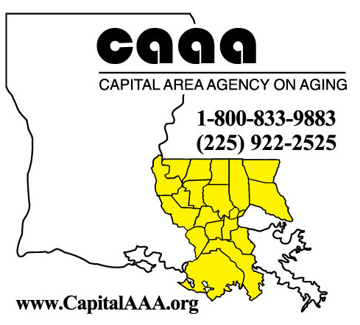

“Your Life,
Your Health”

Diabetes
Self-Management Workshop
Join a FREE 2 ½ hour “ Your Life, Your Health” Diabetes workshop, held one day a week for six weeks in a community setting near you.

Learn from trained volunteers and professional leaders with health conditions themselves

Set your own goals and make a step-by-step plan to improve your health – and your life.
Capital Area Agency on Aging
P.O. Box 66038
Baton Rouge, LA 70896

Name: _________________________

Address: _________________________

_________________________
_________________________
“The workshop helped me understand that I’m not alone”.
Workshop participant

Phone: _________________________

For additional details, visit our website at

www.capitalaaa.org

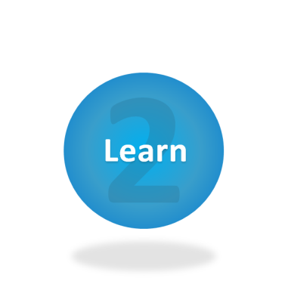
Are you sick and tired of being sick and tired?
There is help!

You don’t have to stop doing the things you love to do. The key to getting the most out of life is learning to manage your symptoms.

“Your Life, Your Health” Diabetes workshops can assist you in taking control of your condition.

A caregiver or relative is welcome to attend with you. They too will benefit.

Living with Diabetes can affect your quality of life. This workshop will give you the support you need to find practical ways to deal with your condition, discover better nutrition and exercise choices, and learn better ways to talk with your doctor and family about your health.

Our FREE, six-week “Your Life, Your Health” Diabetes workshop is designed to help you better manage your Diabetes and gain control of your health!

To register, get more information or find out when the next workshop starts, please call Susan:
225-922-2525 or 1-800-833-9883

“Your Life, Your Health” Diabetes workshops will help you learn how to:

- Manage symptoms

- Communicate effectively with your doctor and other healthcare professionals

- Lessen your frustration

- Fight fatigue

- Build your confidence

- Eat healthy

- Monitor your blood sugar

- AND...get more out of life!

Learn how to feel better...healthier...happier

