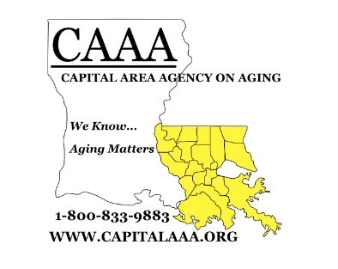
Capital Area Agency on Aging HEALTH FAIR EXPO SPONSOR/EXHIBITOR FORM
October 4, 2022
Lamar Dixon Expo Center, Gonzales, LA

The mission of Capital Area Agency on aging is to advocate and provide services to enhance
the quality of life for older adults.

☐Exclusive Presenting Sponsor - $7,500

☐Platinum Sponsor - $5,000

☐Gold Sponsor - $3,500

☐Silver Sponsor - $2,500

☐Bronze Sponsor - $1,000
☐Support Sponsor - $500
☐Friends - $50 to $499
(Sponsorship Benefit Information on Next Page)

☐Exhibitor Fee - $175 (Includes one 6’ table and one lunch) Table covering needed: YES_____ NO_____
☐Nonprofit Fee - $100 (Includes one 6’ table and one lunch) Table covering needed: YES_____ NO_____

We request that exhibitors provide one or more door prizes for participants. Over 850 seniors from over 13 parishes participated at our last health fair event.

* Set up at 7:30am – Breakdown at 12:30pm

Exhibitor/Sponsor Information:
Company Name: ___________________________________________________________________________________
Company Address: ______________________________ Contact Name: ________________________________
City: __________________________________________ Contact Email: _________________________________
State: _________________________________________ Contact phone number: _________________________
Zip Code: ______________________________________ I will stay for lunch: YES ___ NO ____
Payable Information:
- Make checks Payable to: CAPITAL AREA AGENCY ON AGING
- Mail checks to: P.O. Box 66038 Baton Rouge, LA 70896
- You may fax completed forms to: (225) 922-2528 Attention: Health Fair Expo or email completed form to dlyons@capitalaaa.org
- If you have questions please call (225) 922-2525 and ask for Dusty Lyons.

ALL FUNDS RAISED WILL BE USED TO SUPPORT INCREASING DEMANDS FOR ELDER SERVICES. CAAA IS A TAX EXEMPT NON PROFIT 501c3 ORGANIZATION. Your contribution may be tax deductible.

Capital Area Agency on Aging HEALTH FAIR EXPO SPONSOR SHEET
Set up 7:00am – Break down 12:00pm

Exclusive Presenting Sponsor - $7,500

- Listed as presenting sponsor/rights to have logo posted on CAAA social media sites
- 20 minutes to present health/wellness initiative to participants
- Rights to company representation at head table to deliver participant welcome
- Designation as presenting sponsor with logo on event program
- Rights to company logo on CAAA Annual Report
- Four 6’ tables in prominent location on day of event

Platinum Sponsor - $5,000

- Listed as platinum sponsor/rights to have logo posted on CAAA website
- 7 minutes to present health/wellness initiative to participants
- Designation as platinum sponsor with logo on event program
- Rights to company logo on CAAA Annual Report
- Two 6’ tables in prominent location on day of event

Gold Sponsor - $3,500

- Listed as gold sponsor on CAAA website
- Designation as a gold sponsor with logo on event program
- 2 minute presentation on day of event
- Rights to company logo on CAAA Annual Report
- Company name acknowledged as a lunch sponsor
- Two 6’ special color skirted table in prominent location on day of event

Silver Sponsor - $2,500

- Listed as silver sponsor on CAAA website
- Designation as silver sponsor on event program
- One minute presentation on day of event
- Rights to company logo on CAAA Annual Report
- One 6’ skirted table in priority location day of event

Bronze Sponsor - $1,000

- Listed as bronze sponsor on CAAA website
- Designation as bronze sponsor on event program
- One 6’ table in preferred location on day of event

Support Sponsor - $500
- One 6’ table on day of event
- Signage on designated table
- Listed as support sponsor on event program

Friends - $50 to $499
- Listed as Friends on event program

