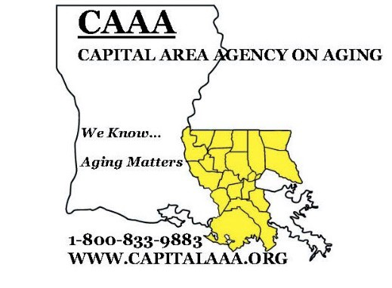
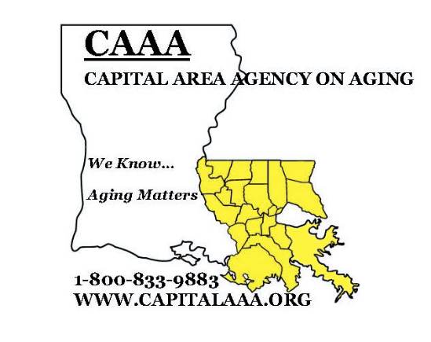
P.O. Box 66038, Baton Rouge, LA 70896-6038
Carrolton Office Building
6554 Florida Blvd, Suite 221
Baton Rouge, LA 70806
Telephone: (225) 922-2525
Fax: (225) 922-2528

Dear Madame or Sir,

Thank you for your interest in the Louisiana SenioRx Program, Enclosed are the enrollment forms you need for SenioRx. In order to assist you, please complete these forms and return them with copies of the documents listed below:

- Medicare Card (front and back) if applicable
- Proof of Income (Social Security benefit letter, copy of recent income tax return(if you file income tax), W-2 forms(if you still work), yearly interest income statements, pension benefits statement, etc,)
- Insurance Cards (front and back) ie Peoples Health, BlueCross, Humana, etc.
- Copy of Insurance Explanation of Benefits or Pharmacy Print-Out (beginning this year to current date) if you have prescription drug insurance

The SenioRx program can only assist you with medications that are taken on a monthly basis
for chronic conditions. Please fill out these forms completely, You should list only the
medications that you are NOW taking and need help paying for, This list should include
name of drug, strength, how often taken, and the name, address, phone & fax number of the
prescribing physician, Failure to include ALL requested information will cause your application
to be delayed or returned to you.

If you have any questions, please call our office at (225) 287-7414 in Baton Rouge or
l-800-280-0908 if you're outside the Baton Rouge area. We look forward to helping you
get your medications for free or at reduced prices.

Sincerely,

Louisiana SenioRx Staff ELSIE DICKERSON, DUSTY LYONS, STACEY MILLER
Capital Area Agency on Aging

The Louisiana SenioRx Program is administered by the Governor's Office of Elderly Affairs, The information being collected will be kept STRICTLY CONFIDENTIAL


pg 1

PLESE COMPLETE ALL INFORMATION & Louisiana SenioRx Program
RETURN THIS TO : P.0. Box 66038
Baton Rouge, LA 70896-6038

CLIENT APPLICATION
Social Security Number: __________ Medicare Number ______________
----------
Part A effective date: Part B effective date____________
Last name:_______________________________ First Name:___________________________
Mailing Address:______________________________ Street Address:________________________
City: ______________________ Zip _______ Parish:_____________ Home Phone_____________
Email ________________________ Cell phone________________
Race/Ethnicity: White__ African American__ Hispanic:__ Other:__

Gender: Male:__ Female:___ Birth date: _ /_/
Rent_ Own__ Other __

Did you file income taxes last year? Yes__ No__ Are you a legal US resident? Yes__ No__
Employment Status: Retired__ Disabled__ Work full time__ Part Time__
Are you a veteran or a veteran’s spouse/widow? Yes__ No__
Marital Status: Married_ Single__ Widowed__ Spouse's Name:___________________
Spouse's Social Security Number:_____________ Spouse's birth date: ____
Number living in household (including client):___

Emergency Contact:
Name:_________________________________ Address:
--------------
Phone:_________________________________ Relationship : ______________________________________

ATTACH COPIES OF YOUR PROOF OF INCOME (SOCIAL SECURITY LETTER OR W2)
We must have a copy of proof of income for you and your spouse if living in your household.

TOTAL MONTHLY INCOME: $_____ TOTAL ANNUAL INCOME $________ _
Salary/Wages $___________ Unemployment $_______ Social Security Disability $ ______
Veteran’s Benefits $__________ Child Support $____________ Social Security $_______________
Workman’s Comp $____________ Pension $__________ SSI $___________ Interest Income $_____
Railroad Retirement $ Other (i.e. public assistance) $ _

MEDICAL INFORMATION
ATTACH COPY OF ALL INSURANCE CARDS WITH APPLICATION (front & back of cards)

Are you currently enrolled in any prescription assistance or discount programs? Yes No ______
Do you have insurance covering prescription drugs? Yes____ No___
Have you voluntarily canceled state, federal or private prescription coverage in six months? Yes__ No_
Are you enrolled in ___Medicare __VA Benefits ___SLMB _____QMB # __
Do you have any health insurance coverage? Company and Policy #__________
Do you have a Medicare Advantage or Medigap Policy?___ Company and Policy #_______________

PLEASE LIST YOUR DRUG ALLERGIES:

_________________________________________________________________________________

 pg 2

PLEASE LIST ALL MEDICATIONS YOU NEED HELP OBTAINING

Medication | Directions / Strength | Name Prescribing Doctor
1.
2.
3.
4.
5.
6.
7.
8.
9.
10.
11..

PLEASE LIST CONTACT I NFORMATION FOR ALL THE PHYSICIANS WHO PRESCRIBE
THE CURRENT MEDICATIONS that you cannot afford

Name of Doctor | Complete Mailing Address | Office Phone Number & FAX
1.
2.
3.

I hereby state that the information I have given is correct to the best of my knowledge and the Louisiana SenioRx Program has my permission to obtain and release information as deemed necessary to obtain my medication s. I understand that the Louisiana SenioRx Program cannot guarantee assistance. I understand that omitting or falsifying information is grounds for denial of services.

Signature _ _ Date __



pg 3

PATENT CONSENT AND RELEASE FORM

EXCHANGE OF INFORMAION
I give permission to authorized representatives of the Louisiana SenioRx to inspect my medical records whenever necessary to obtain pertinent information needed to solicit medications on my behalf from companies that manufacture or provide medications through patient assistance programs. I also authorize SenioRx to discuss my medical needs and me with my physician when necessary. Additionally, I give SenioRx permission to verify my income through the Social Security Administration, my employer, Veterans Administration or any other company, business or organization from which I receive income. This authorization is good as long as SenioRx is assisting me or until I revoke such.

I want a copy of this form to be accepted as a valid consent to share information.

If I do not sign this form, information will not be shared, and I will have to contact each agency, company, or organization individually to give them the information about me that they need.

DATE OF BIRTH_____________ SOCIAL SECURITY NUMBER ______________________

ADDRESS

FULL PRINTED NAME OF PATIENT ______________________________________________

SIGNATURE_____________________________________________ DATE ______

PATIENT SIGNATURE AUTHORIZATION

I authorize representatives of Louisiana SenioRx (Elsie Dickerson, Dusty Lyons, Stacey Miller) to sign forms on my behalf for the purpose of soliciting medications on my behalf from companies that manufacture or provide medications through patient assistance programs. This signature authorization is good as long as SenioRx is assisting me or until I revoke such.

PRINT FULL NAME OF CLIENT_____________________________________

SIGNATURE_________________ DATE _



pg 4

YOU HAVE THE FOLLOWING RIGHTS WITH RESPECT TO YOUR INFORMATION:

-You have the right to request restrictions on certain uses and disclosures of your information. We are not required to agree to a restriction that you request. We cannot agree to limit the uses or disclosures of information that are required by law.

-You have the right to inspect and copy your information as long as we maintain the information. Simply submit a written request to us. We may charge you a fee for the costs of copying, mailing or other supplies that are needed to grant your request.

-You have the right to request that we amend your information that is incorrect or incomplete. To request an amendment, submit a written request to the servicing agency, 'along with the reason for the request. We are not required to amend information that is already accurate and complete.

-You may request communications of your information by alternative means or at alternative locations. For example, you may request that we contact you about matters only in writing or at a different residence or post office box. To request identical communication of your health information, you must submit a written request to the Council on Aging location providing services. Your request must state how or when you would like to be contacted; we will accommodate all reasonable requests.

For more information or to report a problem:

If you have questions or would like additional information about our privacy practices, you may contact the Louisiana Governor's Office of Elderly Affairs at PO Box 61, Baton Rouge LA 70821-0061 or (225) 342-7100. If you believe your privacy rights have been violated, you can file a complaint with the Office of Elderly Affairs at the above address. There will be no retaliation for filing a complaint.

I have read the information and rights in this application:

Client
Signature Date

Agency issuing notice: CAPITAL AREA AGENCY ON AGING
Address: 6554 FLORIDA BLVD SUITE 221, BR LA 70806
Telephone: (225)-287-7414

pg 5

